**LIBRARY MANAGEMENT SYSTEM**

# **Purpose**

* Create an automation system for librarians as a creating book.
* Our general purpose in this project is make the management easier for librarians with some methods. Like “Add book”, “List Books” and “Search books”.

# **Project**

## **Classes and Subclasses**

1. IBOOK <<Interface>>
2. Library
3. Book
4. Type(Abstract)
5. PoemBook
6. NovelBook
7. DetectiveBook
8. ChildBook
9. Main

## **Data Types and Access Modifiers**

* private (-): accessible within the enclosing class.
* public (+): accessible from everywhere in the program.
* protected (#): accessible within the same package or subclasses in different packages.
* default(null): accessible only within the same package.

1. IBOOK <<Interface>>

boolean isAvailable();

1. Library

private ArrayList<Book> books;

1. Book

private String title;  
 private String author;  
 private int pageCount;  
 private Type type;  
 private boolean status;

1. Type(Abstract)

protected ArrayList<Book> listBook;

1. PoemBook
2. NovelBook
3. DetectiveBook
4. ChildBook
5. Main

## **Methods**

* The get method returns the variable value.
* The set method sets the value.

1. IBOOK <<Interface>>
2. Library

public Library()

public ArrayList<Book> getBooks()

public void setBooks(ArrayList<Book> books)

public Book searchBook(String s)

public void addBook(Book b)

1. Book

public Book(String title,String author,int pageCount,Type type,boolean status)

public String getTitle()

public void setTitle(String title)

public String getAuthor()

public void setAuthor(String author)

public int getPageCount()

public void setPageCount(int pageCount)

public Type getType()

public void setType(Type type)

public boolean isStatus()

public void setStatus(boolean status)

public boolean isAvailable()

public String toString()

1. Type(Abstract)

public ArrayList<Book> getListBook()

public abstract void setListBook(ArrayList<Book> var1)

public abstract void addBook(Book var1)

1. PoemBook

public PoemBook()

public void setListBook(ArrayList<Book> listBook)

public void addBook(Book b)

1. NovelBook

public NovelBook()

public void setListBook(ArrayList<Book> listBook)

public void addBook(Book b)

1. DetectiveBook

public DetectiveBook()

public void setListBook(ArrayList<Book> listBook)

public void addBook(Book b)

1. ChildBook

public ChildBook()

public void setListBook(ArrayList<Book> listBook)

public void addBook(Book b)

1. Main

public static void main(String[] args)

public static void book()

## **Outputs**

* When user runs the application, firstly user see this main menu.

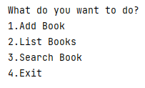

* **Case 1:** Provide to user add book into the library and want the entries as regard book information from user.
* Entry1(requested as a String):

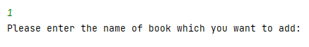

For example, this entry has been: Daha

after entering the book name, user see question 2 for 2nd entry.

* Entry2(requested as a String):



For example, this entry has been: Hakan Gunday

after entering the author, user see question 3 for 3rd entry.

* Entry3(Requested as an integer):



For example, this entry has been: 417

after entering the number of pages, user see question 4 for 4th entry.

* Entry4(Requested as an integer from choice options):

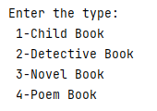

For example, this entry has been: 3

The book’s type is specified as a “Novel Book”.

after entering the type of book, user see question 5 for 5th entry.

* Entry5(Requested as 1 or 2):

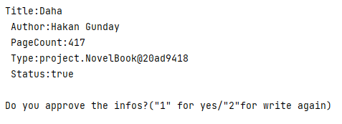

On this process Entries are showed user to check for the entries. Asked for is information true.

* Case 1:



Specified the book has been added and returns the main menu.

* Case 2:



Returns to questions again.

* **Case 2:** Provide to user lists the books which has been in library according to type.
* Entry 1(Requested as an integer from the choice below):



For example, this entry has been: 3

after entering the integer that shows type of the book, user see list of the novel books. Also showed the books that have been added.

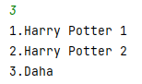

After showed the books returns to main menu.

* **Case 3:** Provide to user Search the books in library and shows their status. User should write truly name of the books.
* Entry 1(Requested as a String):



For example, this entry has been: Harry Potter 1

after entering the name of the book, user can see the book’s info with status.

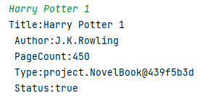

After showed the book’s info returns to main menu.

* **Case 4:** Provide to user exit from the application.

## **UML Diagram**

